GitHub User Stories (GitHub Issues)

To manage project requirements in an organized manner, 25 user stories were created as individual GitHub Issues. Each issue represents a specific feature or functionality from the user's perspective and includes the corresponding acceptance criteria. This approach follows Agile software development practices, making it easier to plan, track, and manage the implementation of the SafeBite platform.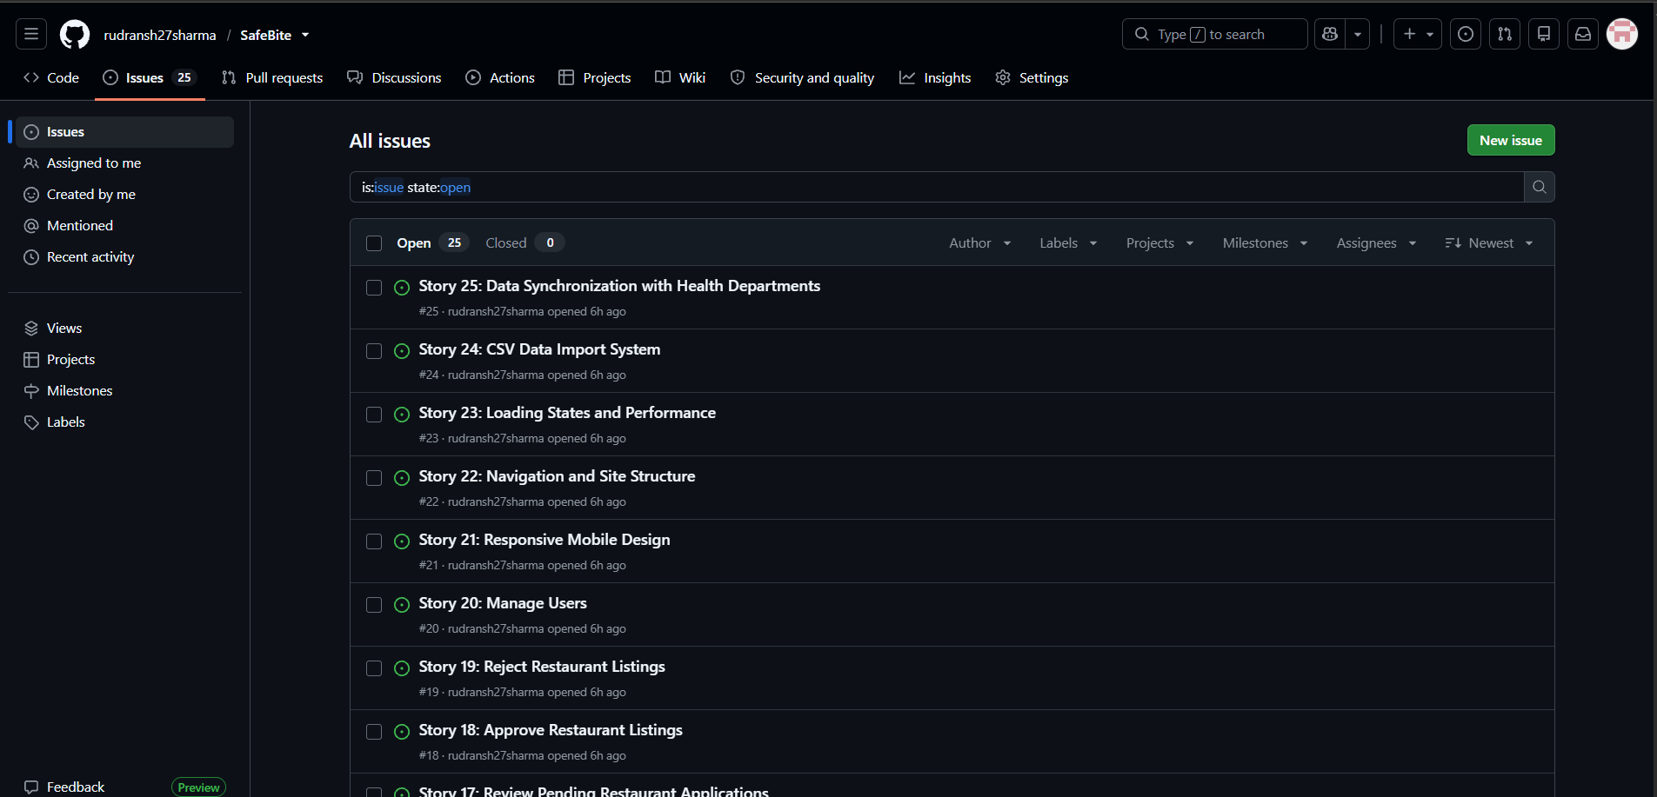

SafeBite – MoSCoW Prioritization
This document summarizes the MoSCoW prioritization for the SafeBite MVP based on the defined user stories.

Must Have (Critical for MVP)
· Story 1 – User Registration
· Story 2 – User Login
· Story 4 – Browse Restaurant Listings
· Story 7 – View Restaurant Details
· Story 8 – View Safety Score
· Story 13 – Create Restaurant Listing
· Story 17 – Review Pending Restaurant Applications
· Story 18 – Approve Restaurant Listings
· Story 21 – Responsive Mobile Design
· Story 24 – CSV Data Import System

Should Have (Important for User Experience)
· Story 3 – Role-Based Access Control
· Story 5 – Filter Restaurants by Criteria
· Story 6 – Search Restaurants by Name
· Story 9 – View Inspection History Timeline
· Story 14 – Edit Restaurant Information
· Story 15 – View Listing Approval Status
· Story 19 – Reject Restaurant Listings
· Story 22 – Navigation and Site Structure
· Story 23 – Loading States and Performance

Could Have (Nice to Have Features)
· Story 10 – View Inspection Violation Details
· Story 11 – View Inspector Information
· Story 12 – View Violation Photos
· Story 16 – Manage Multiple Restaurant Locations
· Story 20 – Manage Users
· Story 25 – Data Synchronization with Health Departments

Won't Have (Future Releases)
· Advanced Analytics Dashboard
· Live Notifications
· Mobile Application
· Customer Review System

Wireframe Submission Format
Screen | Purpose | Key UI Elements
1. Login / Sign Up | User authentication | Email, Password, Login, Register
2. Home Page | Browse restaurants | Search bar, Categories, Restaurant cards
3. Restaurant Details | Restaurant information | Safety score, Images, Details
4. Owner Dashboard | Restaurant management | Listing status, Edit button
5. Admin Dashboard | Approve/Reject listings | Pending applications, Approve/Reject

1. Login / Sign Up
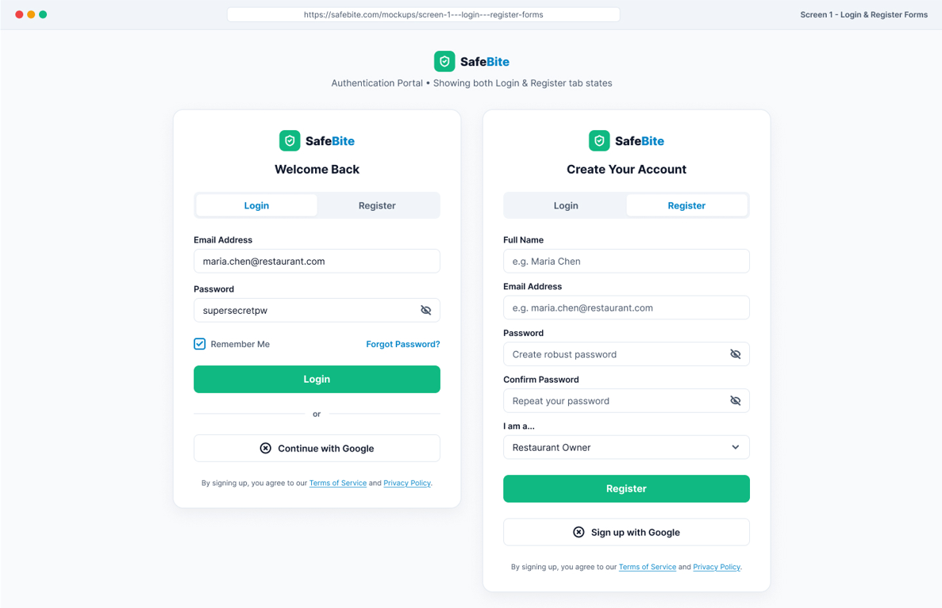

2. Home Page
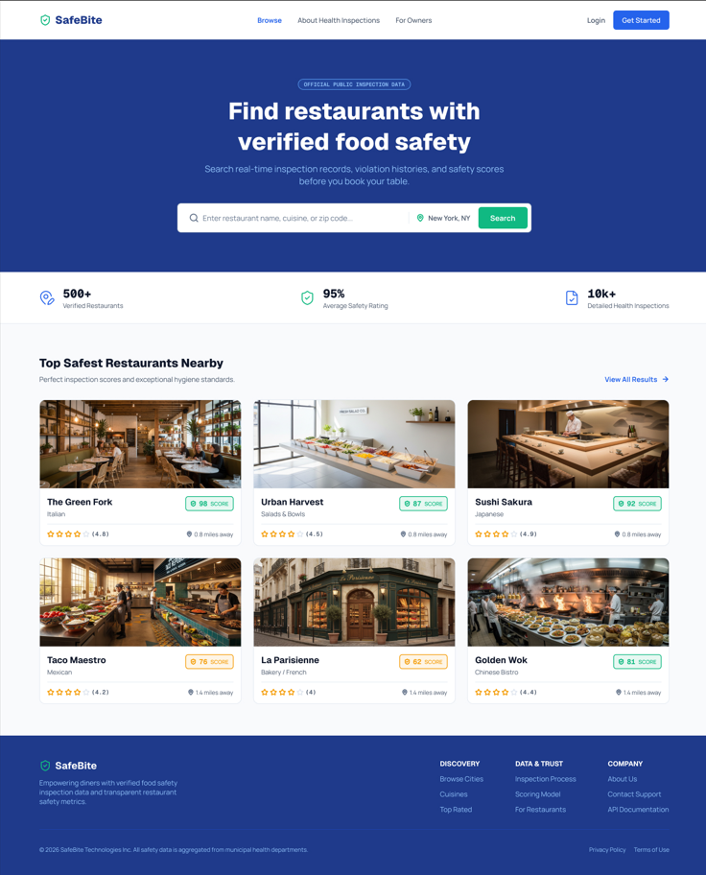

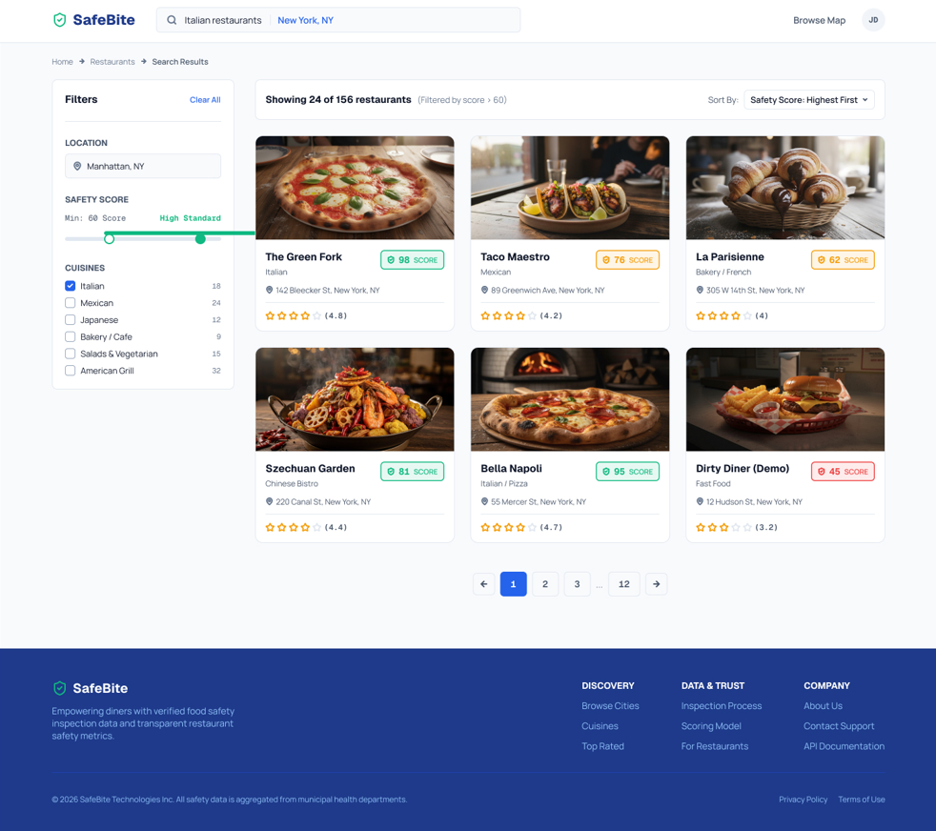

3. Restaurant Details
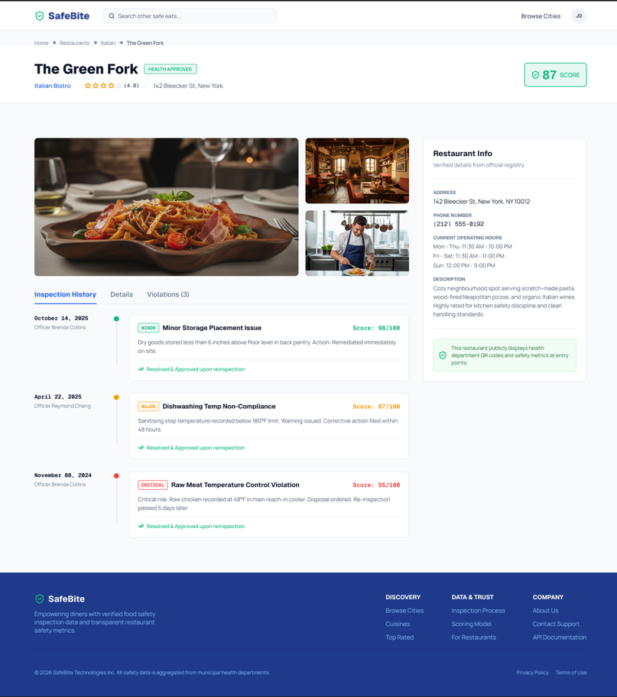

4. Owner Dashboard
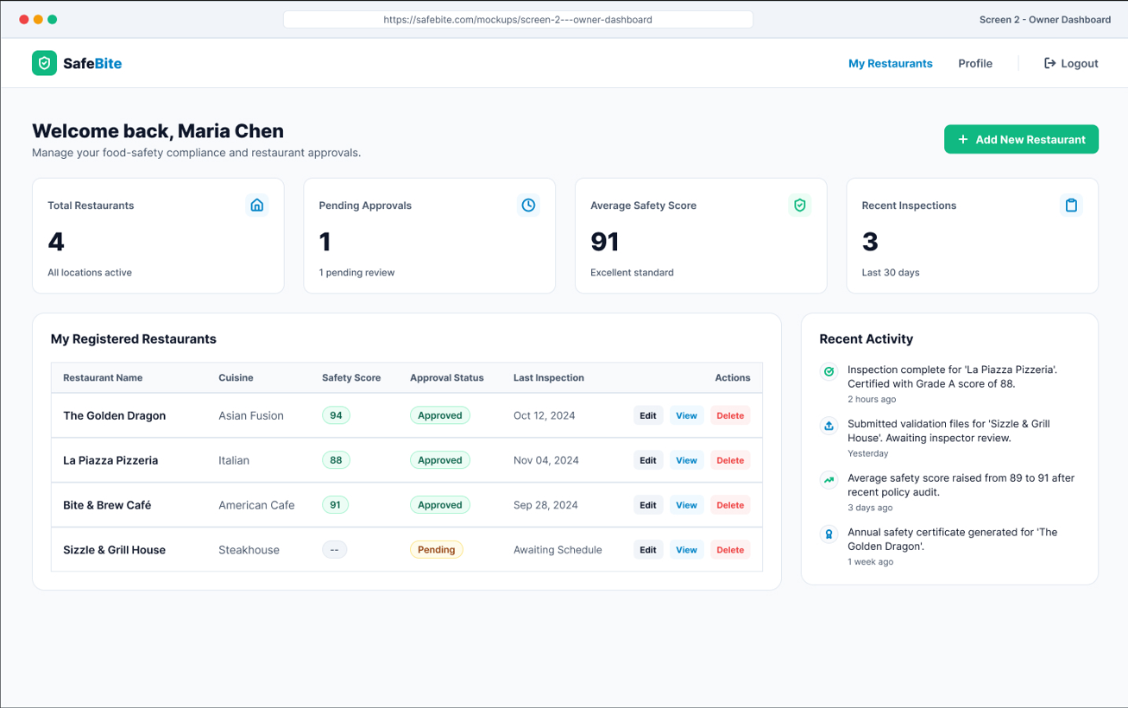5. Admin Dashboard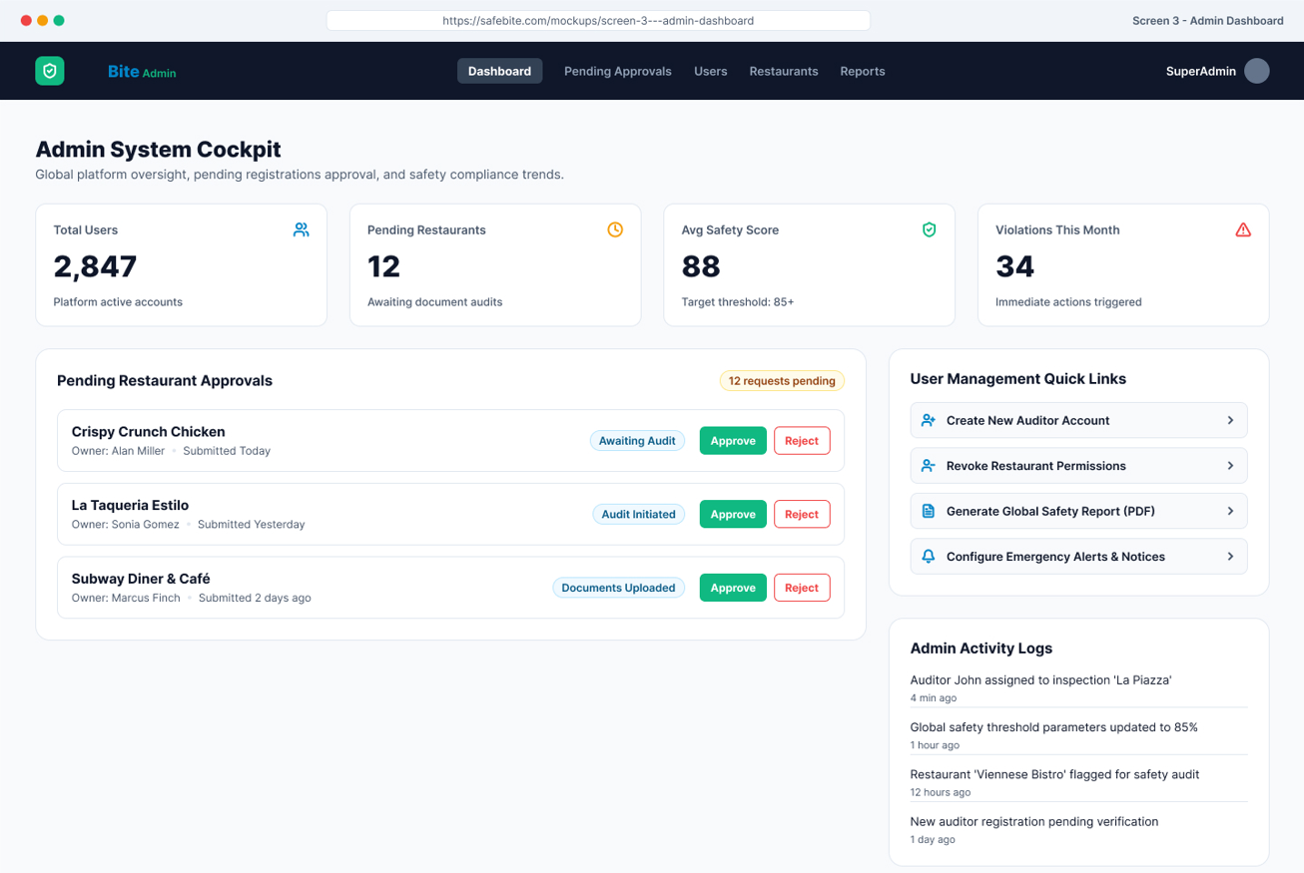

4. Architecture Diagram (Draw.io)

Title
SafeBite – Restaurant Food Safety Platform Architecture

Format
- Single-page architecture diagram
- Landscape orientation
- Created using Draw.io

Purpose
Illustrates the overall architecture of SafeBite, showing how users interact with the frontend, backend, database, deployment infrastructure, and data sources.

Components Included

Frontend
- React 18 (Vite)
- Tailwind CSS
- Customer, Restaurant Owner, and Admin interfaces

Backend
- FastAPI REST API
- JWT Authentication & Role-Based Access Control
- Restaurant Management
- Inspection History API
- Approval Workflow

Database
- SQLite (Development), PostgreSQL-ready
- Stores users, restaurants, inspections, violations, and inspector data

Data Source
- CSV files for restaurants, inspections, violations, inspectors, and users
- Database initialized from CSV datasets

Containerization
- Docker & Docker Compose
- Separate frontend and backend containers
- Shared network for communication

Deployment
- Docker Compose (Development)
- Cloud-ready deployment
- Optional Nginx Reverse Proxy and HTTPS support

External Services
- Government inspection datasets
- Future integrations (Google Maps, Email, SMS)

Data Flow
- Users access the React application.
- Frontend sends API requests to the FastAPI backend.
- Backend authenticates users using JWT.
- Business logic processes requests.
- Backend retrieves data from the SQLite database.
- Inspection and restaurant data are returned as JSON.
- Frontend displays restaurant details, inspection history, and safety scores.

Diagram Requirements
The diagram should include:
- Frontend
- Backend
- Authentication Layer
- Database
- CSV Data Source
- Docker Containers
- Deployment Infrastructure
- External Services
- Clearly labelled arrows showing data flow between components.

